**TECHNOCRATS SUMMER TASK**



**TASK-1**

**INSTRUMENTS**

**SUBMITTED BY:**

Rohan Bhojwani

(Robocon-Electrical)

**MULTIMETER:**

Multimeter is a very important device when it comes to garage. It plays a major role in debugging the problems in bots. Now starting with the very basics of the multimeter, it has 3 probe-ports.

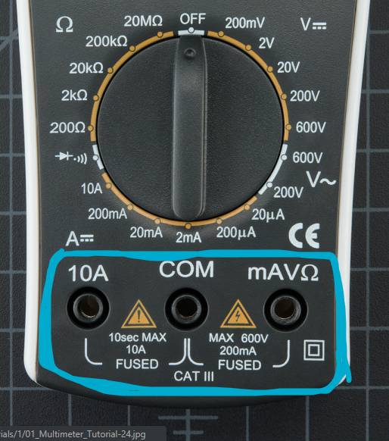

The black probe is inserted in “COM” port. The red probe is inserted in “V ohm mA” port. The red probe is inserted in “10A” port when the larger value of ampere has to be detected.

**MEASURING VOLTAGE:**

While measuring voltage place your probes on the wire and get the value detected.

NOTE:

* If you get a negative value that simply means the probes are oppositely placed. Place the probe otherwise and you get a positive value.
* When you don’t have any idea about the approximate value of voltage then simply set your multimeter value on “200m” and if you see “1” on display then set the multimeter on next bigger measurement scale.

**MEASURING RESISTANCE:**

Pick out a random resistor and set the multimeter to the 20kΩ setting. Then hold the probes against the resistor legs with the same amount of pressure you when pressing a key on a keyboard

The meter will read one of three things, **0.00**, **1**, or the **actual resistor value**.

* In this case, the meter reads 0.97, meaning this resistor has a value of 970Ω, or about 1kΩ (remember you are in the 20kΩ or 20,000 Ohm mode so you need to move the decimal three places to the right or 970 Ohms).
* If the multimeter **reads 1** or displays **OL**, it's overloaded. You will need to try a higher mode such as **200kΩ** mode or **2MΩ** (megaohm) mode. There is no harm if this happen, it simply means the range knob needs to be adjusted.
* If the multimeter reads **0.00** or nearly zero, then you need to lower the mode to **2kΩ** or **200Ω**.

**MEASURING CURRENT:**

The process is just similar like that of measuring voltage and resistance.

The only thing to be kept in mind is that when you suspect the current to be higher than that of “200mA” then change the red probe’s port from “V ohm mA” to “10A” port.

**NOTE:**

If you suspect the current values to be really high then make sure to measure values of short period of time because higher value of current of longer period of time can damage the fuse of multimeter.

**CHECKING CONTIN0UITY:**

Checking continuity is checking the resistance to be less than few ohms. It simply means that your resistance between two points is too small that is actually acts as an element offering no resistance.

**Points to be kept in mind while debugging using continuity:**

When a system is not working, continuity is one more thing to help troubleshoot the system. Here are the steps to take:

1. If the system is on, carefully check VCC and GND with the voltage setting to make sure the voltage is the correct level. If the 5V system is running at 4.2V check your regulator carefully, it could be very hot indicating the system is pulling too much current.
2. Power the system down and check continuity between VCC and GND. If there is continuity (if you hear a beep), then you've got a short somewhere.
3. Power the system down. With continuity, check that VCC and GND are correctly wired to the pins on the microcontroller and other devices. The system may be powering up, but the individual ICs may be wired wrong.
4. Assuming you can get the microcontroller running, set the multimeter aside, and move on to serial debugging or use a logic analyzer to inspect the digital signals.

**Continuity and large capacitors:** During normal troubleshooting. You will be probing for continuity between ground and the VCC rail. This is a good sanity check before powering up a prototype to make sure there is not a short on the power system. But don't be surprised if you hear a short 'beep!' when probing. This is because there are often significant amounts of capacitance on the power system. The multimeter is looking for very low resistance to see if two points are connected. Capacitors will act like a short for a split second until they fill up with energy, and then act like an open connection. Therefore, you will hear a short beep and then nothing. That's ok, it's just the caps charging up.

**TYPES OF MULTIMETER:**

**ANALOG MULTIMETER:** In such multimeters the display is analog that is you have to read the value manually displayed by meter pointer.

**DIGITAL MULTIMETER:** in such multimeter the value is displayed digitally.

**FLUKE MULTIMETER:** In such multimeters all you need to do is set the dial on what value you want to measure. For e.g. Voltage, ampere, etc.

The remaining task for caliberating the range of multimeter is done by the multimeter itself.

**SUGGESTION:** this is the multimeter by HTC. The specialty of this mutlimeter is that is it has calibration certificate i.e. it provides highly accurate values upto three decimals places. Moreover, it also measures frequency which can also help us in debugging process in some or the other way.

<https://www.amazon.in/HTC-Digital-Multimeter-Calibration-Certificate/dp/B07572NW5Y>

**REFERENCES:**

<https://learn.sparkfun.com/tutorials/how-to-use-a-multimeter/all#measuring-resistance>

<https://www.elprocus.com/multimeter-types-and-applications/>

**CLAMPMETER:**

While multimeter is a device that mainly focuses on voltage measurements

Clamp meter is mainly devised to measure current. Apart from it clamp meter

also measures voltage, resistance and continuity. The other major difference

between multimeter and clamp meter is that the later can measure values in a

Single a piece of conductor where as in multimeter you require two probes (since

it is focused to measure potential difference) i.e. you don’t need to break the

circuit for measuring the values.

**NOTE**: since clamp meter is mainly focused to measure higher current values like up to 400A.

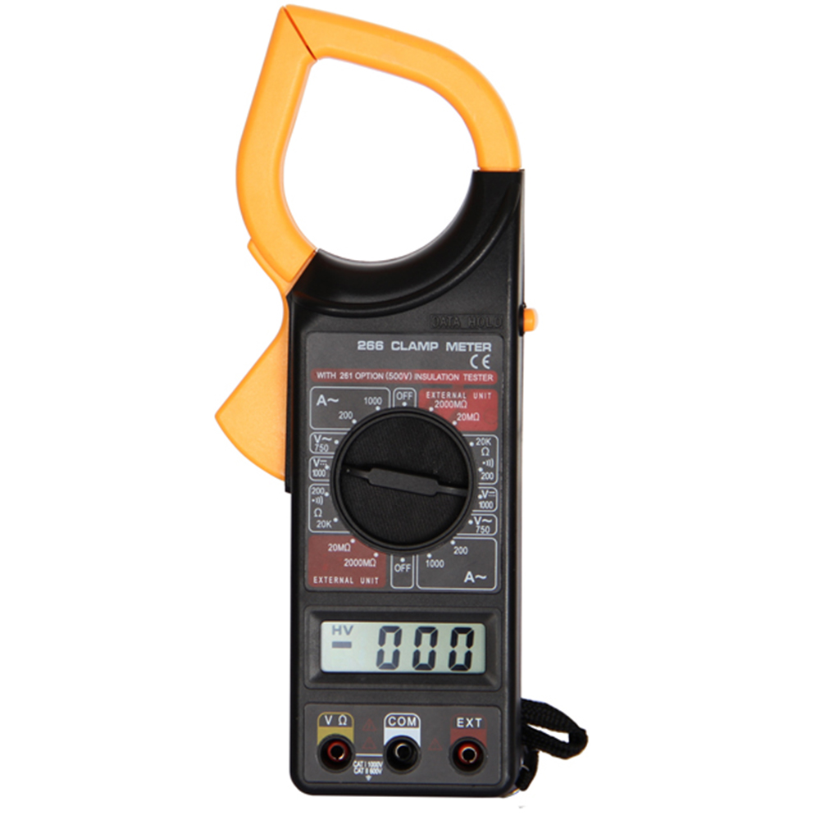**PS**: using clamp meter could be really difficult task in garage because while making robot in a very small and limited place it could be tough to insert the “too large” clamps of clamp meter.

**OSCILLOSCPE:**

What can it measure?

* **Timing characteristics**:
  + **Frequency and period** -- Frequency is defined as the number of times per second a waveform repeats. And the period is the reciprocal of that (number of seconds each repeating waveform takes). The maximum frequency a scope can measure varies, but it's often in the 100's of MHz (1E6 Hz) range.
  + **Duty cycle** -- The percentage of a period that a wave is either positive or negative (there are both positive and negative duty cycles). The [duty cycle](https://learn.sparkfun.com/tutorials/pulse-width-modulation/duty-cycle) is a ratio that tells you how long a signal is "on" versus how long it's "off" each period. (We can use the feature of duty cycle to check our motor drivers i.e. whether they are working as coded duty cycle).
  + **Rise and fall time** -- Signals can't instantaneously go from 0V to 5V, they have to smoothly rise. The duration of a wave going from a low point to a high point is called the rise time, and fall time measures the opposite. These characteristics are important when considering how fast a circuit can respond to signals.(seems to be a nice feature but not sure whether it can be used in any way in garage)
* **Voltage characteristics**:
  + **Amplitude** -- Amplitude is a measure of the magnitude of a signal. There are a variety of amplitude measurements including peak-to-peak amplitude, which measures the absolute difference between a high and low voltage point of a signal.
  + **Maximum and minimum voltages** -- The scope can tell you exactly how high and low the voltage of your signal gets.
  + **Mean and average voltages** -- Oscilloscopes can calculate the average or mean of your signal, and it can also tell you the average of your signal's minimum and maximum voltage.

**USES OF OSCILLOSCOPE IN GARAGE:**

* Determining the **frequency and amplitude** of a signal, which can be critical in debugging a circuit's input, output, or internal systems. From this, you can tell if a component in your circuit has malfunctioned.
* Identifying how much **noise** is in your circuit.

**PS:**  The above content is copied but seems to be highly substantial when it comes to understanding of O-scope and usage of it in garage.

**REFERENCE:**

<https://learn.sparkfun.com/tutorials/how-to-use-an-oscilloscope/all>

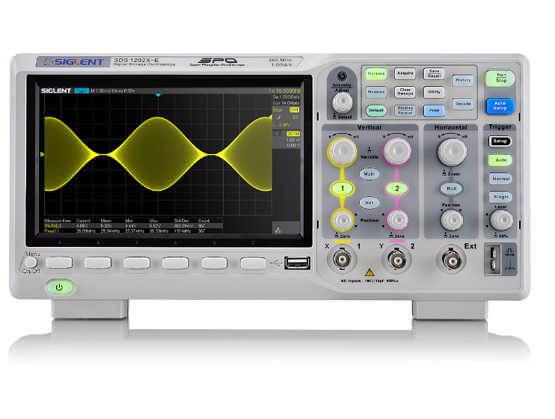

**TACHOMETER:**

It’s a really simple device which is used to measure rotations made by an instrument.

For garage purposed “non-contact type tachometer” can be used. A non-contact type tachometer has laser light emitted. There is light receiver as well which detects the light getting rebounded and thus tells about the rotations made.

A “non-contact type tachometer” which can be used in garage

<https://www.amazon.com/Digital-Photo-Laser-Tachometer-Contact/dp/B001N4QY66?ref_=Oct_BSellerC_15729791_0&pf_rd_p=0683492a-4f0c-51d2-b8f6-ed52f04191a4&pf_rd_s=merchandised-search-6&pf_rd_t=101&pf_rd_i=15729791&pf_rd_m=ATVPDKIKX0DER&pf_rd_r=6CX2QJSFQ277CNBY7BGG&pf_rd_r=6CX2QJSFQ277CNBY7BGG&pf_rd_p=0683492a-4f0c-51d2-b8f6-ed52f04191a4>